# Home Page User Manual: Personal Time Manager

### Overview

The Home Page serves as the central hub for managing your tasks. It displays an overview of your Upcoming Tasks and provides easy access to essential task management features such as searching tasks, adding tasks, and viewing analytics.

### Features and Functionality

1. **Section Title: "Upcoming Tasks"**
   * Displays the tasks you have scheduled, sorted by date and time.
   * This allows you to quickly review the next five tasks on your agenda.

1. **Task List**
   * Displays up to 5 tasks in a visually appealing blue task card format.
   * Each task card contains:
     + **Task Name:** The title of the task (e.g., "Project Due Date").
     + **Task Date and Time:** The scheduled date and time range (e.g., "2024/12/10 - 1:00 AM to 12:00 PM").
     + **Task Tag:** A category or context for the task (e.g., "School" or "Personal").
     + **Delete Button:** A red trash can icon that allows you to delete a task. Clicking this prompts a confirmation dialog before deleting the task.

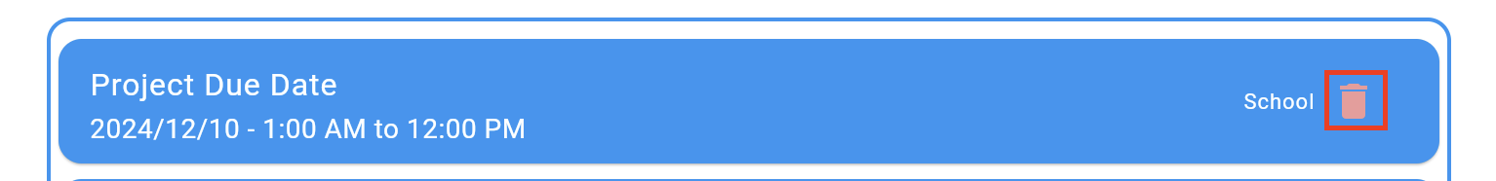

1. **Buttons Below the Task List**
   * Positioned at the bottom of the screen, these buttons allow you to navigate to other core features of the app:
     + **Search Tasks**
       - Opens the Search Tasks page, where you can search for tasks based on specific criteria such as date, name, or tag.
     + **Add Task**
       - Opens the Add Task page, where you can input details to create a new task.
     + **Time Usage Analytics**
       - Opens the Analytics Page, where you can view reports on how your time is being spent across different tasks and categories.

### Common Actions

* **Delete a Task:**
  1. Locate the task in the task list.
  2. Click the red trash can icon next to the task.
  3. Confirm the action in the dialog box.
* **Navigate to Other Pages:**
  1. Use the Search Tasks, Add Task, or Time Usage Analytics buttons at the bottom of the page to explore further functionalities.
* **Review Upcoming Tasks:**
  1. View the next five tasks at a glance. Tasks are automatically sorted by their scheduled date and time.

### Additional Notes

* If no tasks are available, the page will display a message: "No upcoming tasks."
* The task list dynamically updates as tasks are added, edited, or deleted.